**State Diagram for a Push Down Automata**



**Formal Description of Finite State Machine**

**Defining Seven Tuples of our FSM :**

**M=(Q, Σ, δ ,Γ,q0, Z, F)**

1. Q ( q0 , q3 , q1 , q2 ) **Set of States**
2. Σ **(** ( , ) , 0 , 1 , 2 , 3 , 4 , 5 , 6 , 7 , 8 ,9 **) Set of Inputs**

**State q0 :**

Push an element ‘**(**‘ , if the stack is empty and do nothing. If you get any number from 0-9 then move to state 3 and do nothing.

**State q3 :**

If state machine gets **numbers** on state 3 then loop otherwise brute-force forcefully change to the state q1.

**State q1 :**

If there is ‘**)**’ pop ‘**(**‘ until there is no ‘**)**’ left and if the stack is empty move to state q2 (Final State).

If on state ‘q1’ operations **+ , - , * , /** occurs move back to state q0.

**State q2 :** State q2 is the final state accepting the Valid Expression.

**Output on J-Flap :**

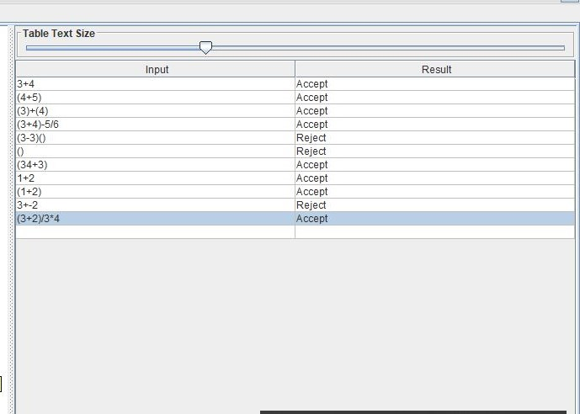

**Language Description :**